Book

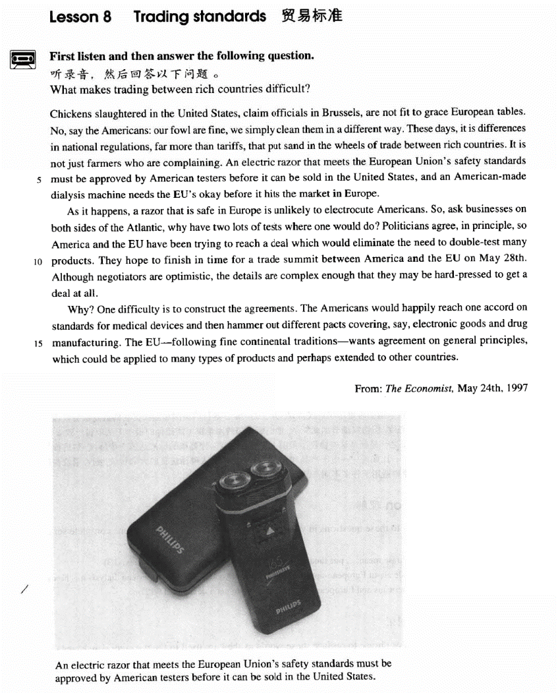

课文

Chickens slaughtered in the United States, claim officials in Brussels, are not fit to grace European tables.

布鲁塞尔的官员说，在美国屠宰的鸡不适于用来装点欧洲的餐桌。

No, say the Americans: our fowl are fine, we simply clean them in a different way.

不，美国人说，我们的家禽很好，只是我们使用了另一种清洗方式。

These days, it is differences in national regulations, far more than tariffs, that put sand in the wheels of trade between rich countries.

当前，是各国管理条例上的差异，而不是关税阻碍了发达国家之间的贸易。

It is not just farmers who are complaining.

并不仅仅是农民在抱怨。

An electric razor that meets the European Union's safety standards must be approved by American testers before it can be sold in the United States, and an American-made dialysis machine needs the EU's okay before it hits the market in Europe.

一把符合欧洲联盟安全标准的电动剃须刀必须得到美国检测人员的认可，方可在美国市场上销售；而美国制造的透析仪也要得到欧盟的首肯才能进入欧洲市场。

As it happens, a razor that is safe in Europe is unlikely to electrocute Americans.

碰巧在欧洲使用安全的剃须刀不大可能使美国人触电身亡，

So, ask businesses on both sides of the Atlantic, why have two lots of tests where one would do?

因此，大西洋两岸的企业都在问，当一套测试可以解决问题时，为什么需要两套呢？

Politicians agree, in principle, so America and the EU have been trying to reach a deal which would eliminate the need to double-test many products.

政治家在原则上同意了， 因此，美国和欧洲一直在寻求达成协议，以便为许多产品取消双重检查。

They hope to finish in time for a trade summit between America and the EU on May 28th.

他们希望尽早达成协议，为5月28日举行的美国和欧洲贸易的最高通级会议作准备。

Although negotiators are optimistic, the details are complex enough that they may be hard-pressed to get a deal at all.

然谈判代表持乐观态度，但协议细节如此复杂，他们所面临的困难很可能使他们无法取得一致。

Why? One difficulty is to construct the agreements.

为什么呢？困难之一是起草这些协议。

The Americans would happily reach one accord on standards for medical devices and then hammer out different pacts covering, say, electronic goods and drug manufacturing.

美国人很愿意就医疗器械的标准达成一个协议，然后推敲出不同的合同，用以涵盖 -- 比如说 -- 电子产品和药品的生产。

The EU -- following fine continental traditions -- wants agreement on general principles, which could be applied to many types of products and perhaps extended to other countries.

欧洲人遵循优良的大陆传统，则希望就普遍的原则取得一致，而这些原则适用于许多不同产品，同时可能延伸到其它国家。

词汇讲解

### fit

* **fit** [fɪt] adj. 适合的

**fit** adj. **英文解释：**of a good enough standard for sb. or sth. 适合的（强调达到足够号的标准）

**be fit for …** 适合的（强调达到足够号的标准）

= **be fit to do …**

* The food **is not fit for** human consumption.
* He **is not fit to** govern this country.

**【近义词】**表达“适合的”：

**suitable** （强调看上去协调的）

* I haven’t any **suitable** clothes for the wedding.
* The present isn’t **suitable** for an old man.

**appropriate** adj. 适当的；恰当的；合适的

* Your dress is **appropriate** for a formal party.

**felicitous** adj. 恰当的；善于措辞的；幸福的（强调话说的很适合）

* **felicitous** remarks

**proper** （没有场合限制）

### grace

* **grace** [greɪs] v. 使荣耀；装饰，装点
* The queen **graced**（使荣耀） us with her presence.
* Her face has **graced**（装饰，装点） the covers of magazines across the world.

**【同根词】**

**graceful** adj. 优雅的；优美的

**disgrace** n. 耻辱；丢脸；vt. 使……失宠

**disgraceful** adj. 不名誉的，可耻的

**【近义词】**表达“使荣丢人”：

**shame**

**humiliate**

**bring shame / disgrace on …**

### standard

* **standard** ['stændəd] n. 标准，水准，水平
* safety / moral / living **standards**
* a high / low **standard** of living
* International **Standards** Organization (ISO)

**【近义词】**表达“标准”：

**criterion** / **criteria** n. 标准 （强调公司、组织的标准）

* admission **criterion**
* the **criteria** we use to select candidates

**yardstick** / **benchmark** n. 标准（书面语）

* The **yardstick** / **benchmark** of truth is practice.
* **Gre写作范文：**
* Some people believe that a society has to place its overall success before the well-being of its members to achieve prosperity, whereas others believe that the only **benchmark** of the well-being of a society is the general welfare of all its people. Admittedly, a society should pursue its overall success, but from my perspective this goal will never be attained unless and until the well-being of all its individual citizens is properly respected.
* **Gre写作范文：**
* To sum up, I concede that the overall success of a society is important indeed. However, without sufficient emphasis on personal welfare, not only would the motivations of a society’s citizens be weakened, but the philosophical underpinnings of democracy would also be undermined. Therefore, the only **yardstick** of the well-being of any society, I believe, is not its overall success, but the general welfare of all its people.

### electrocute

* **electrocute** [ɪ'lektrəkju:t] v. 电死，以电刑处死

**electrocute** v. **英文解释：**to kill a person or an animal by means of an electric current

**【同根词】**

**execute** vt. 实行；执行；处死

= **carry out**

* **execute** one’s command / one’s will
* He was **executed** for treason.

**persecute** vt. 迫害；困扰；同…捣乱

* Jews were **persecuted** by Nazis.

**prosecute** vt. 检举；贯彻；从事；依法进行 vi. 起诉

* Trespassers will be **prosecuted**.

### eliminate

* **eliminate** [ɪ'lɪmɪneɪt] v. 彻底清除

**eliminate** v. **英文解释：** to completely get rid of sth. that is unnecessary or unwanted彻底清除

* Many infectious diseases have been virtually **eliminated**.

**eliminates the need for …** 使某事成为多余…

* The credit card **eliminates the need for** cash or checks.

**【近义词组】**表达“清除”：

**remove**

**get rid of**

**root out**

**eradicate** (“**radi**”=root radish)

* **eradicate** crime / poverty

**【辨析】**

**abolish** vt. 废除，废止；取消，革除

* **abolish** slavery
* **abolish** capital punishment / death penalty

### accord

* **accord** [ə'kɔ:d] n. 协议，条约 （一般指国际条约）

**【近义词组】**表达**“条约”**：

**accord** / **treaty**

**pact** / **compact** n. 协定；公约；条约；契约 （一般的很条约，没有场合）

**contract** n. 合同

**deal** n. 交易

**agreement** n. 协议；同意，一致

### hammer out

* **hammer out** ['hæmə aut] v. 敲定了……

**hammer out sth** **英文解释：**to decide on an agreement, contract etc. after a lot of discussion and disagreement 敲定了……

* The two countries finally **hammered out** an agreement.

**【近似词组】**表达“达成协议”：

**reach / come to an agreement** 达成协议

**keep / honor an agreement** 履行协议

**【反似词组】**

**break / violate an agreement** 违背协议

课文讲解

# （标题）

# Trading standards

知识点（1）

**英文解释：**

**trading** adj. 贸易的，商业的

* **trading** standards 贸易标准
* **trading** partner 贸易伙伴

# （第一段）

# Chickens slaughtered in the United States, claim officials in Brussels, are not fit to grace European tables.

**语法分析：**

Chickens slaughtered in the United States（后置定语）, claim officials in Brussels（后置定语，修饰officials）（插入语）, are not fit to grace European tables.

知识点（1）

**写作：**本句话突出的是说话的内容，把说话的人降为插入语

* Chickens slaughtered in the United States, claim officials in Brussels, are not fit to grace European tables.
* **重心偏移：**将说话的人降为插入语
* Officials in Brussels claim that chickens slaughtered in the United States are not fit to grace European tables.
* **突出说话内容：**Lesson03-02
* ‘I’m trying to repair the bell,’ answered Bill（插入语）. ‘I’ve been coming up here night after night for weeks now. You see, I was hoping to give you a surprise.’
* ‘You certainly did give me a surprise!’ said the vicar（插入语）. ‘You’ve probably woken up everyone in the village as well. Still, I’m glad the bell is working again.’
* **突出说话内容：**Lesson03-07
* ‘So long as there’s something to identify, we will give people their money back,’ said a spokeswoman for the Bank（插入语）. ‘Last year, we paid $1.5m on 21,000 claims. ’

知识点（2）

**official** n.政府官员

* a local / embassy **official**

**official** adj.政府的、官方的

* **official** corruption / attitude

**【近义词】**

**bureaucrat** n. （贬义）官僚；官僚主义者

**bureaucracy** n. 官僚主义；官僚机构；官僚政治

**civil** **servant** n. 公务员；政府官员

知识点（3）课文地点介绍

**Brussels**（布鲁塞尔）: the capital and largest city in Belgium（比利时）, centrally situated in northern Europe. Brussels is internationally important as **the headquarters**（总部） of **the European Union (EU)** （欧盟）and **the North Atlantic Treaty Organization (NATO)** （北约）.

知识点（4）

**写作**：自由直接引语 free direct speech

引用某人的说话原文，没有引号；多用于新闻英语

知识点（5）

… are not fit to grace European tables.

委婉表达：这句实际表达的是“美国的鸡不干净”

* **言下之意：**
* Chickens slaughtered in the United States **are of poor quality**.质量低劣
* Chickens slaughtered in the United States **don’t meet European standards**.不符合欧洲标准

**【扩展】**

切记：外交场合；用词不能太直接、不能伤害对方感情

**political correctness** 政治正确

**直接表达** **委婉表达**

unemployed between jobs

She is pregnant. She is knitting a tiny garment.

dustman garbologist

butcher meat technologist

housewife domestic engineer

the disabled / handicapped 残疾的

the physically challenged （委婉）残疾的

the mentally challenged （委婉）智障

the vertically challenged （委婉）侏儒

the horizontally challenged （委婉）肥胖

# No, say the Americans: our fowl are fine, we simply clean them in a different way.

知识点（1）

**fowl** [C]（单复同形）家禽（尤其指鸡）

**poultry** [C]n. 家禽

**livestock** / **stock** [U]n. 牲畜；家畜

# These days, it is differences in national regulations, far more than tariffs, that put sand in the wheels of trade between rich countries.

**语法分析：**

These days, it is（强调句，强调句子主语） differences in national regulations（介词短语当后置定语）, *far more than tariffs（插入语）*, that put sand in the wheels of trade between rich countries.

知识点（1）Lesson03-03

时间状语“当今，现如今”： 指当今**没有**介词“in”

**these days**

**today**

**nowadays**

**in those days** 想当初

* **In those days**, boxers fought with bare fists for prize money.
* **In those days** wandering minstrels were welcome everywhere.

知识点（2）强调句复习

**it is / was … that / who …**

知识点（3）

**more than sth.** 不仅仅是……

* Peace is **more than** the absence of war.

**more than + adj./adv.** 极其/非常……

* He **is more than selfish**. 他自私极了
* **托福听力真题：**

A. She can't help the man look for another platter.

B. She forgot the platter had been broken.

C. She didn't realize the platter had been broken.

D. She doesn't want the man to replace the platter.

* M: I don’t know how I managed to break that platter. I’ll be ***more than* happy** (非常乐意) to buy you a new one.
* W: Forget about it. Some things just can’t be helped.
* Q: What does the woman mean?
* Answer: (D) She doesn't want the man to replace the platter.

**more than A can / could …** 是某人无法、不能… Lesson03-43

* I looked into the boy's serious but eager face and asked him, "Do you want any more books?"
* "Yes, **more than I can** ever get," he replied.
* When my old friend Brian urged me to accept a cigarette, it was **more than I could** bear.
* Dancing proved to be **more than the dish could** bear, for during the party it capsized and sank in seven feet of water.
* The story is **more than I can** believe. (无法相信)
* The beauty of the West Lake is **more than words can** describe.无法描述
* Such a complicated situation is far **more than we could** anticipate and deal with.

知识点（4）

**put sand in the wheels of** [idiom] 阻碍、妨碍

= **put obstacles in the way of** [idiom]

= **stand in the way of** [idiom]

= **hinder**

= **impede**

= **hamper**

* There is none of the hurry which, in our society, often **hampers** the full development of a growing personality.

知识点（5）【课文仿写】

* **造句**：现如今，是风俗习惯的差异，而远不仅仅是语言问题，阻碍了跨国婚姻 (transnational marriage)。
* These days, it is differences in habits and customs, far more than languages, that put sand in the wheels of transnational marriages.

# It is not just farmers who are complaining.

# An electric razor that meets the European Union's safety standards must be approved by American testers before it can be sold in the United States, and an American-made dialysis machine needs the EU's okay before it hits the market in Europe.

**语法分析：**

An electric razor that meets the European Union’s safety standards（that ...定语从句，修饰razor） must be approved by American testers *before（才） it can be sold in the United States**（时间状语从句）*, and an American-made dialysis machine needs the EU’s okay *before（才） it hits the market in Europe（时间状语从句）*.

知识点（1）

**meet** 符合

**【近义词】**表达“**符合**”：

**reach**

**pass**

**live up to**

**satisfy**

**fulfill**

* **~~~** standards 符合标准

知识点（2）

**approve** vt. to officially accept sth. （官方正式）批准

* The budget has been **approved** by the legislature.

**【反义词】**

**reject** vt.驳回

* His application has been **rejected**.

**【辨析】**

**approve of …** 同意

* Catherine’s parents now **approve of** her marriage.

**disapprove of**  不同意

**frown on** 不同意

知识点（3）

**okay**

= **agreement**

= **permission**

= **approval**

* **课文写法替换：**
* … must be **approved** by the EU’s testers.

知识点（4）

**hit** v. arrive at; reach 到达

* **课文写法替换：**
* … before it can be sold in Europe.

知识点（5）

**写作**：contrast 对照；上下文语义相对、故意用不同的结构，让句式更富于变化

* Men always want to be a woman’s first love; *women have a more subtle instinct: what they like is to be a man’s last romance*.

Lesson03-29、Lesson04-05

**写作**：antithesis 对比；；上下文语义相对、句式工整

* There is only one difference between an old man and a young one: the young man has a glorious future before him and *the old one has a splendid future behind him*: and maybe that is where the rub is.
* When poverty comes in at the door, *love leaps out at the window*.
* A mother takes twenty years to make a man of her boy, and *another woman takes twenty minutes to make a fool of him*.

# （第二段）

# As it happens, a razor that is safe in Europe is unlikely to electrocute Americans.

知识点（1）

**as it happen** 碰巧

**as luck would have it** 碰巧

# So, ask businesses on both sides of the Atlantic, why have two lots of tests where one would do?

知识点（1）

**business** [C]n.公司

**business** [U]n.生意、事情

* He has done a lot of **business** here in China.

知识点（2）

**why + do（动词原形）** 质问语气

* **Why worry** about such trifles?

**why not do** 建议做

* **Why not try** to train your character?

知识点（3）

**lot** n. set; collection; group 套、群、组

知识点（4）

**do** v. be enough 足够的

* 对话
* Don't you want something to eat?
* OK. Two burgers will **do**.

# Politicians agree, in principle, so America and the EU have been trying to reach a deal which would eliminate the need to double-test many products.

**语法分析：**

Politicians agree, in principle, so America and the EU have been trying to reach a deal *which would eliminate the need to double-test many products（which...定语从句）*. （so… 结果状语从句）

知识点（1）

**in principle** **英文解释：** if you agree sth. in principle, you agree a general plan or idea but have not yet considered the details 原则上，大致上

* The government has agreed **in principle** to a referendum.

# They hope to finish in time for a trade summit between America and the EU on May 28th.

# Although negotiators are optimistic, the details are complex enough that they may be hard-pressed to get a deal at all.

**语法分析：**

Although negotiators are optimistic（让步状语从句）, the details are complex **enough（如此的）** *that they may be hard-pressed to get a deal at all（结果状语从句）*.

知识点（1）

**optimistic** adj.乐观的

**be optimistic about …** 对…很乐观

* Bankers **are cautiously optimistic about**（谨慎乐观） the country’s economic future.

**【同根词】**

**optimism** n. 乐观；乐观主义

**optimist** n. 乐观主义者；乐天派

**【反义词组】**

**pessimistic** adj. 悲观的，厌世的；悲观主义的

**be pessimistic about …** 对…很悲观

* He **remains** deeply **pessimistic about** the peace process.

**pessimism** n. 悲观，悲观情绪；厌世主义

**pessimist** n. 悲观主义者

知识点（2）

**enough** adj. 足够的

* The room is large **enough** to take another bed.

**【辨析】**

**be … enough to do** 太… 以至于…

= **be so … as to do**

* They **are** rash **enough to** cross the pass on foot.
* They **are so** rash **as to cross** the pass on foot.

= **be … enough that …** 太… 以至于…

= **be so … that …**

知识点（3）

**be hard-pressed to do sth.** 某事太复杂，不大可能成功或发生

* Owing to shortage of staff, the emergency services **were hard-pressed to deal with** the accident.

**be hard-pressed to do sth. at all** 某事太复杂，**根本**不大可能成功或发生

# （第三段）

# Why? One difficulty is to construct the agreements.

知识点（1）

**construct** 起草

* **construct** a sentence 造句
* **construct** an agreement 起草一份协议

# The Americans would happily reach one accord on standards for medical devices and then hammer out different pacts covering, say, electronic goods and drug manufacturing.

**语法分析：**

The Americans would happily reach one accord（协议，同义替换） *on standards（方面状语）* for medical（目的状语） devices and then hammer out different pacts （协议，同义替换） covering, say（插入语）, electronic goods and drug manufacturing（后置定语,修饰pacts）.

知识点（1）

**cover** 涵盖、覆盖、包括了

* The course **covers** all aspects of business and law.

**【近义词】**表达“**涵盖、覆盖、包括了**”：

**embrace** / **encompass**

* The term ‘mankind’ **embraces** / **encompasses** men, women, and children.
* **考研英语（阅读真题）：**
* In the American economy, the concept of private property **embraces** not only the ownership of productive resources but also certain rights, including the right to determine the price of a product or to make a free contract with another private individual.
* **考研英语（阅读真题）：**
* “Anthropology” derives from the Greek words *anthropos* “human” and *logos* “the study of.” By its very name, anthropology **encompasses** the study of all humankind.

知识点（2）

**say / let’s say:** 假定，比方说

* Let’s go out for a walk, **(let’s) say**, along the river.

# The EU -- following fine continental traditions -- wants agreement on general principles, which could be applied to many types of products and perhaps extended to other countries.

**语法分析：**

The EU —following fine continental traditions（插入语）— wants agreement on general principles, *which could be applied to many types of products and* *perhaps extended to other countries*. （which...定语从句）

知识点（1）

**follow** 遵循着、按照…去做

* **对话：**
* —You wanted me dead, Paul.
* —Just **following** orders.
* —Sent me to the chair for sth. I didn’t do, all for your president. You were willing to do that.
* —Just … **following** … orders.

**follow the crowd / herd** 随大流

**follow one’s example / lead** 按照某人的做法跟着做、效法

* I don’t want you to **follow my example / lead** and rush into marriage.

知识点（2）

**continental** adj. 大陆的；欧洲大陆的

* a continental climate

**Continental** 默认欧洲大陆（英语环境）

**the continent / Continent** 默认欧洲大陆（英语环境）

**the channel / Channel** 默认英吉利海峡（英语环境）

知识点（3）

**be applied to …** 被应用于…

知识点（4）

**extend to …** 延伸到

= **spread to …**